**API DOCUMENTATION**

**(Swagger)**

* **Swagger Editor (**<https://editor.swagger.io/>**)**

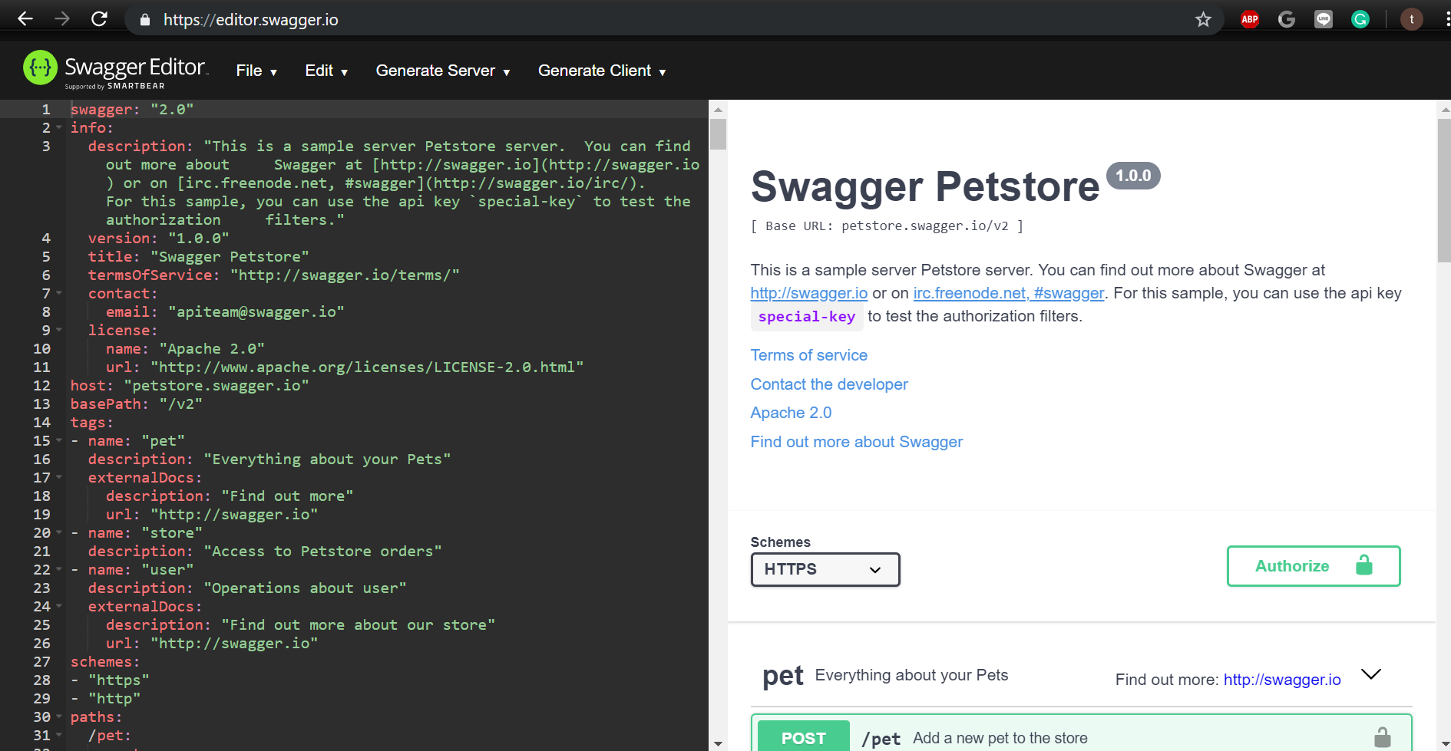

* **info:**

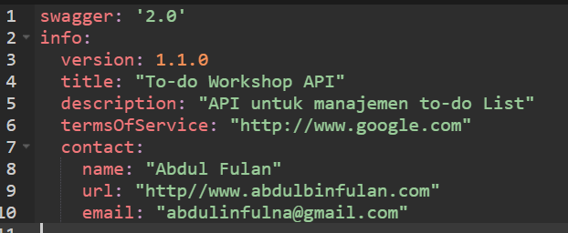

* **host, basePath, tags**

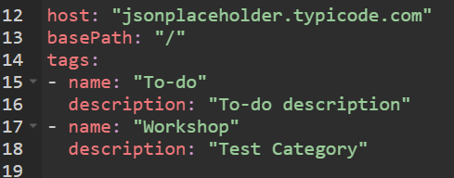

* **paths:**

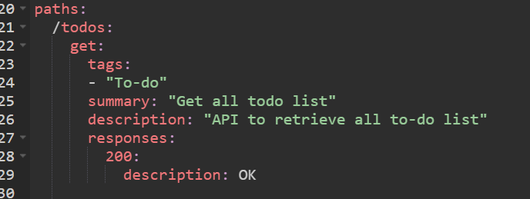

* **paths with parameter**

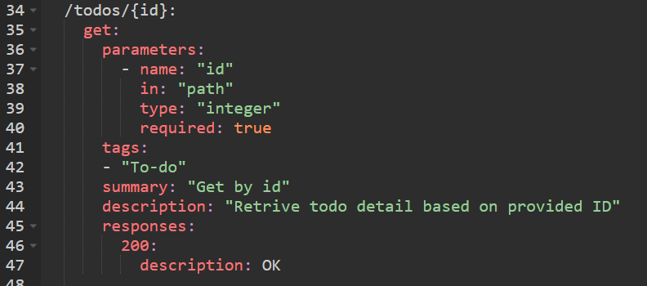

* **Generate Server**

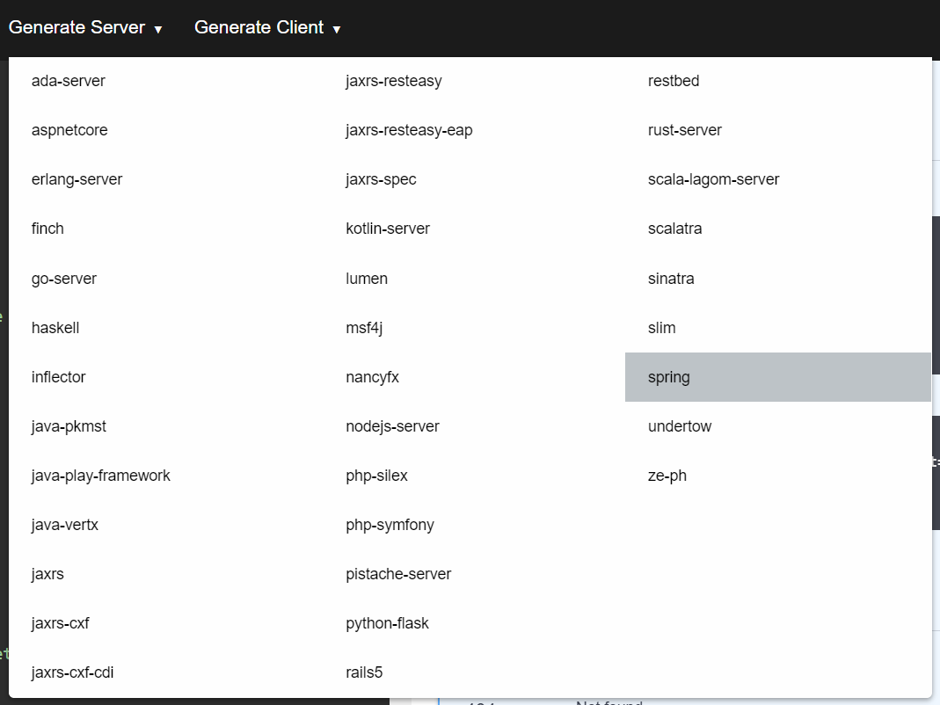

**Integrasi Swagger dan Spring Boot**

* **Dependency (=> pom.xml)**

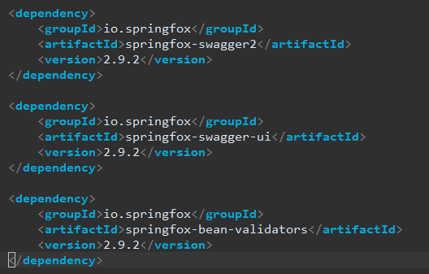

* **Create rest config (agar dapat dibaca oleh swagger) (config class)**

